**STEP 2 is an important step in Online Student Registration**. Residency verification is submitted on this screen; **it is a multi-step process**. Parents can also add/change/delete the student’s address in this step. For residency verification, click on the **Residency Documents** button (lower center of screen).



This causes a pop-up screen to appear with a blue link to upload new files.

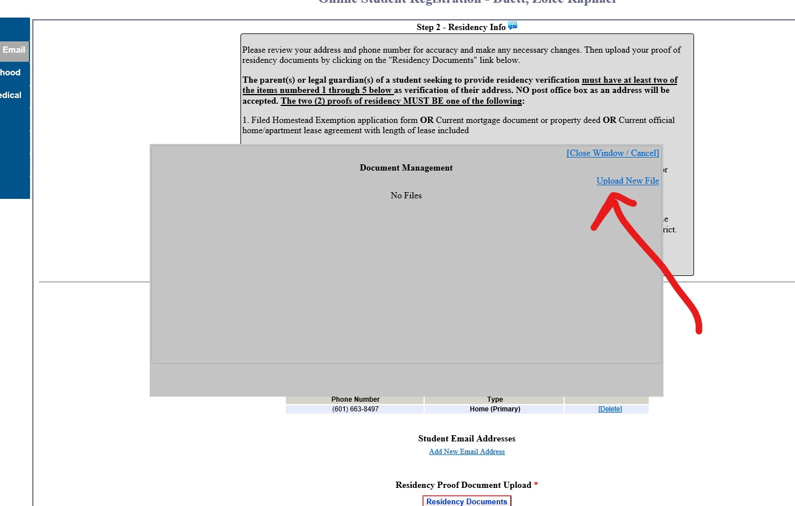

Click on the link to upload new files; the option is given to select files for upload. **This is where residency verification proofs are uploaded in the student registration process.** Click on the Select File button. (If screenshots of residency proofs are on a phone, the user will be directed to the photos folder to choose which screenshot to use. If you are on a computer, select the document from the correct folder).

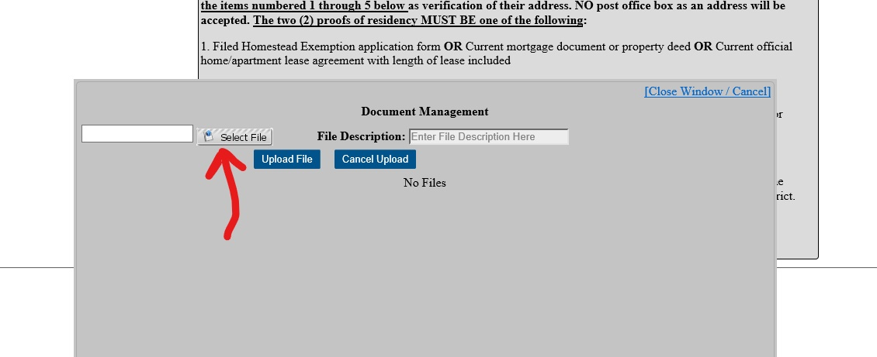

Once the file is selected, the user must: 1) name the file (example: driver license, utility bill, tag receipt, etc.), and 2) click on the button to Upload File (see arrows).

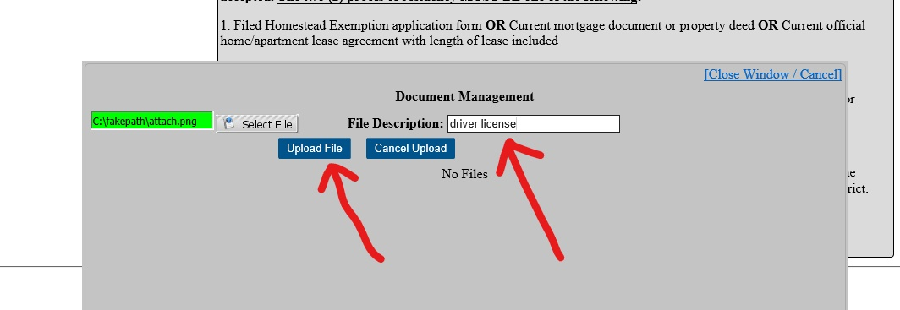

When file successfully uploads, the document is shown on a list. Click on the blue link to Upload New File to add other residency proofs. When all documents have been added, click on the blue link in the pop-up screen to Close Window.

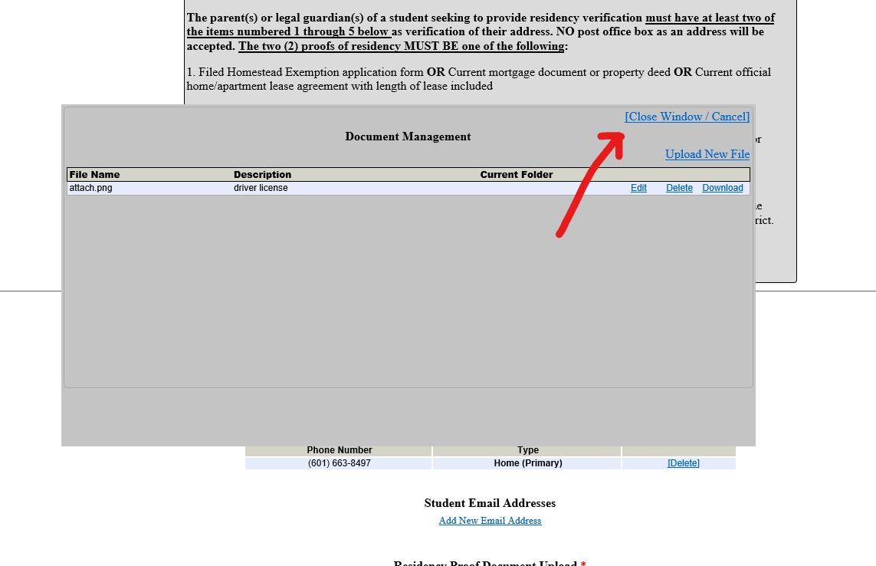

Click on the NEXT STEP button at bottom right of screen to move to the next step in registration process. Proceed through the screens until you reach Step 8, where you verify either: 1) that all info is correct, electronically sign, and click button to Save and Submit; OR 2) at any point, click button on bottom left to save and continue registration at a later time.

**IF A PARENT HAS MULTIPLE CHILDREN IN THE DISTRICT:**

A parent must upload the proofs of residency for the first child and then may copy those documents to other children who are attached to them for registration in Active Parent. On the first screen, above the button for RESIDENCY DOCUMENTS, there is a link labeled “IMPORT DOCUMENTS”. Choose this link and select the student from whom you wish to copy registration documents. This option only requires uploading the documents once for your family and allows you to copy those same documents to each child in your family.