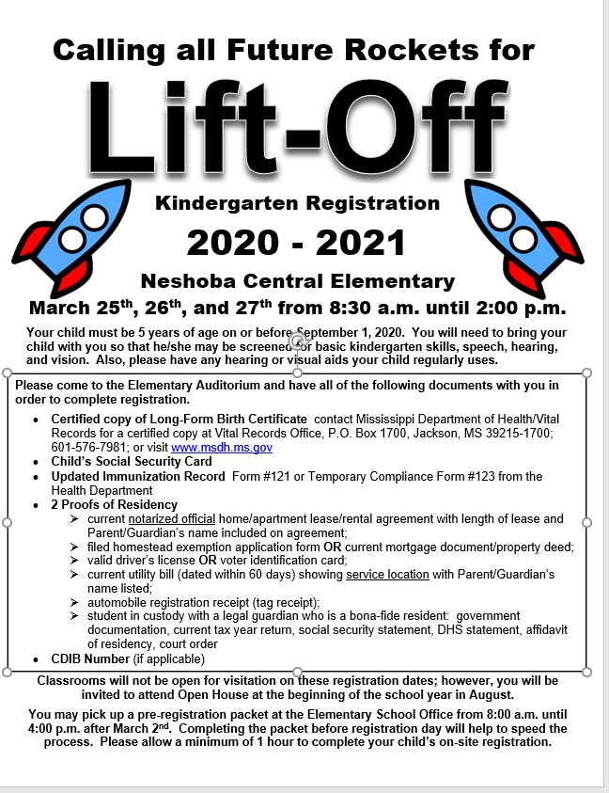
Neshoba Central Elementary School
Student Enrollment Form 2020 - 2021
Enrollment Date: _______________
Student Information Homeroom:
Grade: _____________ Previous Grade: ______________ Transportation: a.m. _________ p.m. __________
Last Name: _______________________ First: _________________________ Middle: ______________________
Suffix: _______________ Preferred Name: _________________________________________________________
Social Security Number:__________________________ Tribal Number: (If applicable) ______________________
Gender: ______________ Check all races that apply: White ____ Black ____His ____ NA ____ AS ____ PI ____
Birthdate: ___________________ Physical Address: __________________________________________________
_____________________________________________________________________________________________
Phone Number: ________________________________________________________________________________
Birth City: ______________________Birth State: ____________________ Birth County: _____________________
Township: ______________________ Range: _______________________ Section: _________________________
Name of Last School Attended: ___________________________________________________________________
Address of previous school if not Neshoba Central: ___________________________________________________

Who does the child reside with: ____ mother ____ father ____ other (list relationship) ______________________
* If not mother or father we must be provided with guardianship documentation. Guardianship papers must include a judge’s signature.

Mother/ Guardian’s Name: _______________________ Father/ Guardian’s Name: __________________________
Address ______________________________________ Address _________________________________________
_____________________________________________ _______________________________________________
Home Phone __________________________________ Home Phone ____________________________________
Cell Phone ____________________________________ Cell Phone ______________________________________
Mother’s Employer _____________________________ Father’s Employer ________________________________
Work Phone Number ___________________________ Work Phone Number _____________________________
Military Affiliation: Military Affiliation:
None ( ) Active Duty ( ) National Guard ( ) None ( ) Active Duty ( ) National Guard ( )

Has student ever attended Neshoba Central? Yes/No If yes, when? ____________________________
Has student ever been enrolled in: Special Education? Yes/ No Speech? Yes/ No Gifted? Yes/ No
Dyslexic Diagnosis? Yes/ No 504 Plan? Yes/ No Tier II/ III? Yes/ No
Has student ever been suspended from school? Yes/No
Has the student ever repeated a grade? Yes/No If yes, what grade(s) __________
Has student ever been expelled? Yes/No Has student been in Alternative School? Yes/No
Has the student ever been enrolled in any daycare or head start programs? Y/N If yes, please list. __________________________________________________________ _______________________________________
List names and relationships (other than listed above) of persons allowed to check out your child or to act on your behalf in the event you can’t be reached. A photo ID is required when your child is released.
1. __________________________________Relationship__________________ph#________________
2. __________________________________Relationship__________________ph#________________
3. __________________________________Relationship__________________ph#________________
4. __________________________________Relationship__________________ph#________________
List names of brothers and sisters enrolled at Neshoba Central:
Name | Relationship | Grade
1. | Brother or Sister
2. | Brother or Sister
3. | Brother or Sister
4. | Brother or Sister

Neshoba Central School District
Residency Registration Checklist 2020 - 2021

Student Name: ____________________________________________________ Grade: ______ in 2020 - 2021

Custodial Parent/Legal Guardian: __________________________________________________________________________________________

Custodial Parent/Legal Guardian Address: ___________________________________________________________________________________

Custodial Parent/Legal Guardian Phone: _____________________________________________________________________________________

According to the Neshoba County School Board policy JBC:
The parent(s) or legal guardian(s) of a student seeking to enroll must provide this school district with at least two of the items numbered 1 through 5 below as verification of their address. NO post office box as an address will be accepted. Every school year, the parent or legal guardian must submit two (2) current proofs of residency in the Neshoba County School District.
The two (2) proofs of residency MUST BE two of the following:
_____ 1. IF RENTING/LEASING: Current notarized official home/apartment lease/rental agreement with length of lease and Parent’s or Guardian’s
Included on lease/rental agreement (THIS MUST BE ONE OF THE PROOFS IF LEASING OR RENTING and one of the following #3-#6)
_____ 2. Filed Homestead Exemption application form OR Current mortgage document or property deed
_____ 3. Valid driver's license OR voter identification card
_____ 4. Current utility bill (dated within 60 days) showing the service location with parent's or guardian's name listed - Acceptable bills:
electricity, gas, water, or landline telephone
_____ 5. Automobile Registration receipt (tag receipt)
_____ 6. Any other document that will objectively and unequivocally establish that the parent or guardian resides within the school district, and in
the case of a student living with a legal guardian who is a bona-fide resident of the school district. (Official government documentation -
i.e. current tax year return, social security statement, DHS statement, etc.)
*NEW STUDENTS OR THOSE WITH CHANGE OF ADDRESS
In addition to two (2) proofs of residency, the verified resident must provide copy of the Property Tax Card, Property Deed, or other document that states the residency property's Section, Township, and Range.
*NOTE:
- Legal guardian(s) must also provide a copy of the court order appointing guardianship. If a petition for guardianship has been filed and the decree is pending, a certified copy of the filed petition for guardianship must be provided.
- If residency is questioned any time throughout the year, the parent/guardian will be required to reprove residency.
- The parent or legal guardian of a NEW student to the district who cannot provide 2 proofs of residency due to circumstances beyond their control, may request a 30-day TEMPORARY admission to school from the Superintendent's office, which will allow them 30 days to become compliant with residency requirements. If 2 proofs of residency cannot be provided at the end of thirty days, the student will no longer be allowed to attend Neshoba County School District.

Permission Agreement *Initial ALL you agree to:
_____ My child has permission to appear in media publications (annual, brochure, newspaper, TV, etc.) when representing NCES.
_____ My child has permission to attend school sponsored field trips.
_____ I give permission for my child to participate in the school’s health program and receive first aid care and health education from the
school nurses.
_____ I give permission for screening of vision, hearing, scoliosis, dental health and general health.
_____ I understand that if false essential information is given above, it may result in immediate dismissal of my child from Neshoba Central
School District.

Parent Signature: _______________________________________ Date: _______________________

School Official Signature: _________________________________ Date: _______________________

