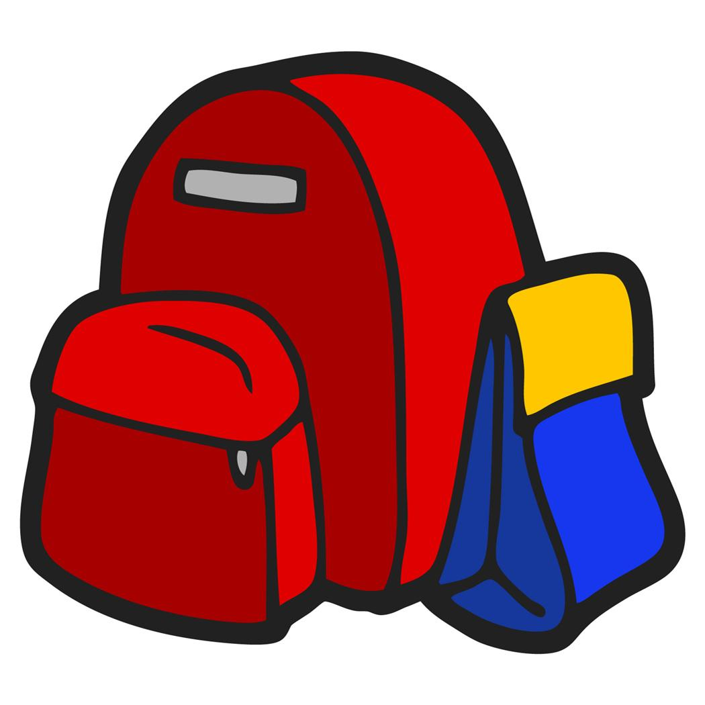
Neshoba Central 4th Grade
School Supply List
2023 - 2024
4 packs #2 Pencils
Cap erasers
Pencil bag (no boxes)
2 packs of crayons
1 pack dry erase markers
Scissors (Fiskars-not pointed)
1 Packs of Glue sticks
Earbuds or headphones
2 plastic pocket folders without brads
3 packs of loose leaf paper
1 pack of highlighters
2 one-subject notebooks
2 packs of 3 x 5 Index cards
2 large box of Kleenex
1 pack of white copy paper
Boys
Germ-X
Quart Ziploc bags
Girls
Gallon Ziploc bags
Clorox wipes

**Only purchase listed supplies. Your child’s teacher will inform you of any additional supplies that will be needed.

