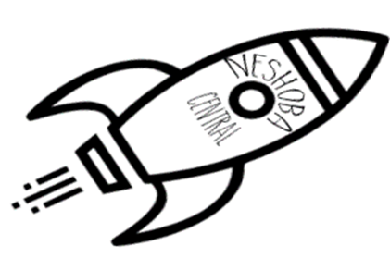
Neshoba Central Elementary
1st Grade Supply List
2023-2024

3 plastic pocket folders (with prongs inside)
2 70-page wide ruled notebook
- package washable markers
2 packages of yellow #2 pencils (USA Gold are our favorites!)
4 boxes 24-count crayons
2 packages dry erase markers (fine tip, black)
1 pair blunt-tipped scissors
3 packages of glue sticks
1 all-purpose zipper bag for supplies
2 boxes of tissue
1 box quart Zip-loc bags
1 box sandwich Zip-loc bags
1 pair of headphones
2 rolls of paper towels
2 bottles of Germ-x

Wish List Items:

Boys: White cardstock Girls: Colored cardstock
Multipurpose cleaner Disinfectant wipes
Laminating sheets Laminating sheets

